CCNA STUDY NOTES 2021/12/15

COMPUTER NETWORKING

# Network devices

## What is a network?

A digital telecommunications network that allows nodes to share resources

What are nodes?

Nodes are electronic devices connected in a network

Common nodes:

|  |  |  |
| --- | --- | --- |
| Router | Switch | Firewall |
| Server | Clients |  |

Building a network

Above are 2 Clients, Alone they are not a network. Because they are not connected.

If you connect them via a cable, then you have formed a network. Now the 2 nodes are connected they share resources

PC1 PC2

### Client

Is a device that accesses a service made available by a server.

### Server

A server is a device that provides functions or services for clients

A client can act as a server.

For example

PC1 PC2

In this case the Pc1 is the client , then PC2 provides a resource to the PC1.

Therefore PC2 is the Server because it provides a resource

*PC1 requests lol.img from PC 2*

*PC2 send the Image file to PC1*

### Switches

Switches have lots of interfaces or ports to plug your pcs an dservers into. They forward traffic within a LAN.

Hosts within the LAN NY can share resources with eachother via S1. Switches cannot connect directly to the internet and send data between the LANs.

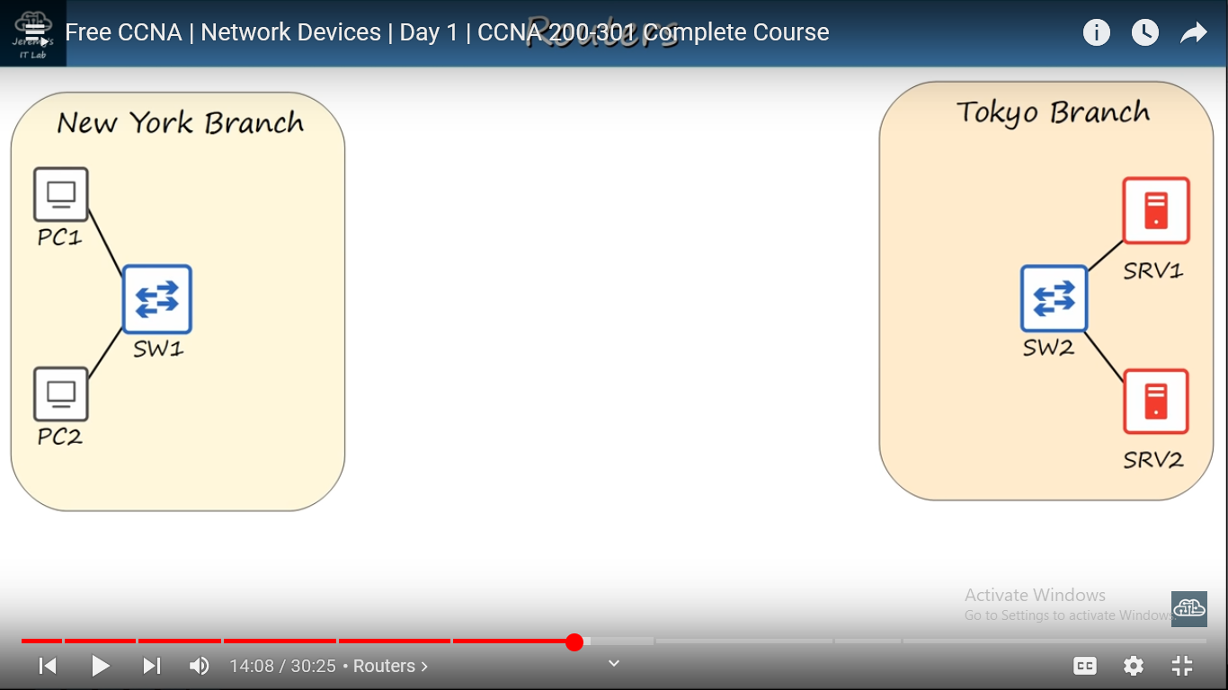

Characteristics of switches

* Have many ports/interfaces 24+
* Provide connectivity for hosts within LANS
* No Connectivity between LANS

EXAMPLES OF SWITCH

Catalyst 9200 and catalyst 3600

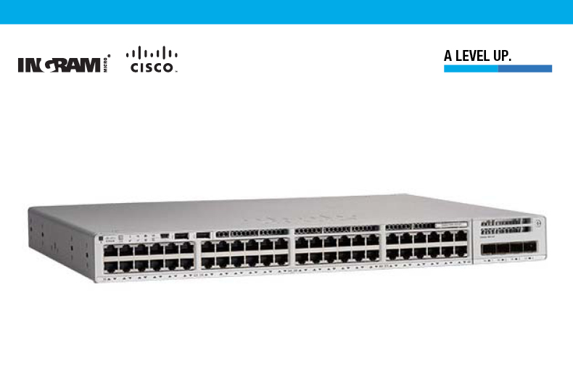

### Routers

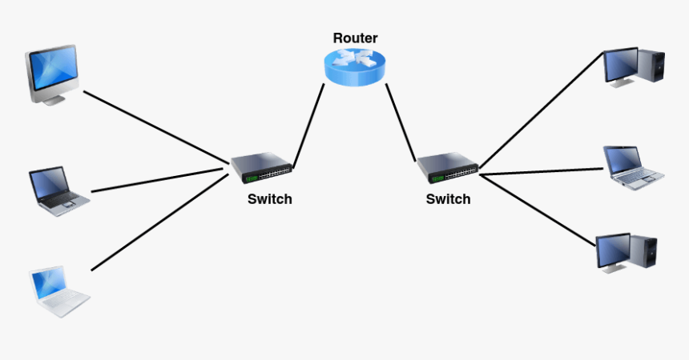

Characteristics

* Have fewer network interfaces than switches
* Forward traffic between different networks ( between lans)
* Used to send data over the internet

### Firewalls

Specialty network devices that control network traffic entering and exiting a netwok.

* Can be placed inside and outside the network

They are configured with security rules that determine which traffic should be allowed or denied in the network.

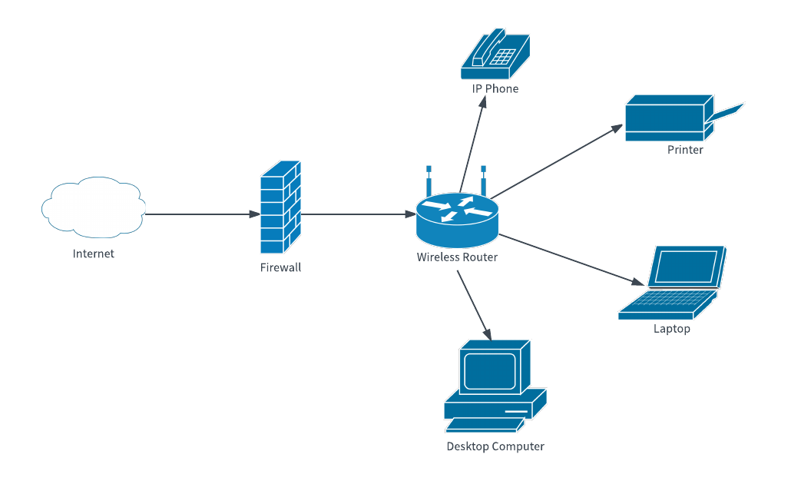

Examples of Firewalls

ASA 5500-X OR FIREPOWER

Modern ASA include features of Next Generation firewalls that include things like IPS (Intrusion Prevention system)

Firepower is a next generation firewall

Characteristics

* Monitor and control traffic based on configuration rules
* Can be placed inside and outside the network
* Next generation firewalls include more advanced filtering capabilities

Network firewalls

Hardware devices that filter traffic between networks

Host based Firewalls

Software applications that filter traffic entering and exiting a host machine like PC